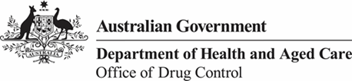

**Export of medicinal cannabis**

## Guidance for cultivators and manufacturers of medicinal cannabis

Version 1.1, November 2024



*© Commonwealth of Australia*

**Ownership of intellectual property rights**

Unless otherwise noted, copyright (and any other intellectual property rights, if any) in this publication is owned by the Commonwealth of Australia (referred to as the Commonwealth).

**Creative Commons Licence**

All material in this publication is licensed under a Creative Commons Attribution 3.0 Australia Licence, save for images, content supplied by third parties, and the Commonwealth Coat of Arms.

Creative Commons Attribution 3.0 Australia Licence is a standard form licence agreement that allows you to copy, distribute, transmit and adapt this publication provided you attribute the work. A summary of the licence terms is available at creativecommons.org/licenses/by/3.0/au/deed.en. The full licence terms are available at creativecommons.org/licenses/by/3.0/au/legalcode.

This publication (and any material sourced from it) should be attributed as: *[Section], [Date], [Full Document Title] - prepared for the Office of Drug Control, Canberra*.

Inquiries regarding the licence and any use of this document should be sent to: [ncs@health.gov.au.](mailto:ncs@health.gov.au.)

**Office of Drug Control**

### Postal address:

GPO Box 9848

Canberra

ACT, 2601

Australia

### Switchboard:

(02) 6289 4618

### Website:

odc.gov.au

The Australian Government acting through the Office of Drug Control (ODC) has exercised due care and skill in the preparation and compilation of the information and data in this publication.

Notwithstanding, the department, its employees and advisers disclaim all liability, including liability for negligence, for any loss, damage, injury, expense or cost incurred by any person as a result of accessing, using or relying upon any of the information or data in this publication to the maximum extent permitted by law.

## **Version control**

Updates to this document will occur automatically on the Office of Drug Control website and the revision table below will list the amendments as they are approved.

|  |  |  |  |
| --- | --- | --- | --- |
| **Date** | **Version** | **Amendments** | **Approved by** |
| April 2018 | 1.0 | Original publication | ODC |
| November 2024 | 1.1 | Revised publication | ODC |

**Table of contents**

**Introduction** 4

**What can be exported?** 4

Appropriate conditions are a prerequisite for an export licence 4

Supply to domestic patients must be maintained 4

**Multiple application processes** 5

**Entry of finished products in the Australian Register of Therapeutic Goods (ARTG)** 5

**Separate and distinct export-only listed goods** 5

Requirements for export-only medicinal cannabis products 6

Applying for an export-only listing 6

**Variations to ODC cultivation, production, and manufacturing licences** 7

How to vary your ODC licences 7

**Obtaining an ODC licence and permit to export** 7

Requirements for an ODC export licence 8

Requirements for an ODC export Permit 8

How to apply for an ODC export licence 8

How to apply for an ODC export permit 8

## **Introduction**

The export of medicinal cannabis products was legalised in February 2018 through the *Narcotic Drugs Amendment (Cannabis) Regulations 2018*.

Such exports must be in conformance with the *Narcotic Drugs Act 1967*, which:

* + gives effect to some of Australia’s obligations under the *Single Convention on Narcotic Drugs, 1961*
  + implements a licensing and permit scheme that regulates the cultivation of cannabis plants and cannabis resin, the production of cannabis or cannabis resin and the manufacture of drugs
* done under a licence and a permit issued by the Office of Drug Control under the *Customs (Prohibited Exports) Regulations 1958*
* made to countries that are willing to issue import permission and who are compliant with the

*Single Convention on Narcotic Drugs, 1961*

* Listed or registered on the Australian Register of Therapeutic Goods



Imports and exports **occur between nations**, at the national or sovereign state level. This means that even if medicinal cannabis is legal at a local or district level, import and export may not be permitted.

## **What can be exported?**

* Medicinal cannabis (e.g. flower) or cannabis resin products manufactured in Australia under a GMP Licence
* Medicinal cannabis (e.g. flower) or cannabis resin products listed as export-only or registered in the ARTG
* Extracts of cannabis (e.g. flower) or cannabis resin manufactured under a *Narcotic Drugs Act 1967* Licence that are not in the final dosage form

# Appropriate conditions are a prerequisite for an export licence

Your medicinal cannabis cultivation, production and manufacture licences need to have the appropriate conditions for an export licence to be granted.

# Supply to domestic patients must be maintained

The ability to export medicinal cannabis has been implemented to allow for the Australian industry to expand and improve supply of medicinal cannabis within Australia.

To ensure licensees are not exporting medicinal cannabis at the detriment of Australian patients, ODC will condition licences to ensure domestic supply and this will be tested as part of the ODC ongoing compliance and monitoring program.

When applying for an ODC export licence for medicinal cannabis, you will need to demonstrate that you will be able to supply medicinal cannabis in Australia for supply under the special access scheme, to authorised prescribers or for clinical trials  
**Multiple application processes**

Because medicinal cannabis is both a narcotic drug and a therapeutic good, requirements of both the *Narcotic Drugs Act 1967* and the *Therapeutic Goods Act 1989* need to be met before you can export medicinal cannabis. Applications are split between the Therapeutic Goods Administration (TGA) and the Office of Drug Control (ODC). You will need to:

### TGA

Enter the finished products in the Australian Register of Therapeutic Goods (ARTG)

### ODC

* Vary your ODC cultivation/manufacturing licences (if they were issued before February 2018, to allow for products to be supplied for export)
* Obtain an ODC export licence an ODC export permit

## **Entry of finished products in the Australian Register of Therapeutic Goods (ARTG)**

Medicinal cannabis products **that are finished products** and are intended to be exported from Australia for commercial supply must first be entered in the Australian Register of Therapeutic Goods (ARTG) in the name of the product sponsor.

The product sponsor is the person responsible for the actual export and who holds the relevant export permissions. The sponsor must be an Australian resident or carrying on business in Australia, but may also have agents acting on their behalf.   
  
ARTG entry can be:

* + registration, which enables supply within Australia as well as
  + export listing as export-only

## **Separate and distinct export-only listed goods**

Applications to list on the ARTG export-only products that are registrable-type medicines, such as medicinal cannabis, are assessed under section 26 of the *Therapeutic Goods Act 1989*. Such products are separately and distinctly listed as export-only products and cannot be supplied in Australia.

However, a good is legally a ‘separate and distinct good’ (see section 16 of the *Therapeutic Goods Act 1989*) if it differs from the export-only listed good in at least one of the following ways:

|  |  |  |
| --- | --- | --- |
| ·         Different formulation | | ·         Different indications |
| ·         Different strength | | ·         Different directions for use |
| ·         Different dosage form | | ·         Different container |
| ·         Different name |  | |

In order to meet the condition on the manufacture licence that you supply domestic patients when requested, you will need to ensure you have product that is ‘separate and distinct’ from the export listed product in a manner described above. For more information: TGA policy for the export of medicines from Australia.

# Requirements for export-only medicinal cannabis products

Medicinal cannabis products that are listed as export-only **must,** as a minimum:

* Not be for domestic supply (‘solely for export’)
* Conform to Good Manufacturing Practice (GMP) requirements (evidence required will depend on whether manufacture is overseas or in Australia)
* Be safe for the purposes for which they are to be used (e.g. indications and manner of use).
* Be of an acceptable presentation with respect to the proposed name, labelling, packaging and any advertising or other informational material associated with the goods (per the definition in the *Therapeutic Goods Act 1989*).
* Conform to any standard(s) applicable to the goods and any prescribed quality or safety criteria, including the standards outlined in *Therapeutic Goods Order No. 93 (Standard for Medicinal Cannabis)*
* Not have been refused registration or listing in Australia
* The Office of Drug Control will be checking any country restrictions on your export listing prior to granting export permission.

The Secretary may accept written confirmation from the country(ies) of import of their willingness to accept the goods if one or more of the above criteria are NOT met.

This written confirmation will acknowledge that:

* The authority understands that there is no history of safe use
* The authority is willing to import the product.

Your export listing will be conditioned so that you may only import to the country or countries for which you have provided this written confirmation.

# Applying for an export-only listing

In order to make an application to the TGA:

1. Obtain a TGA client ID (if you do not already have one)
2. Log in to TGA Business Services
3. Go to ‘Applications’
4. Locate ‘Export Only Medicine’ application types
5. Select ‘S.26 – Export Only: General Listing’ under the ‘Export Only Medicine’ heading
6. Complete the form, including providing necessary attachments
7. Submit by pressing the submit button

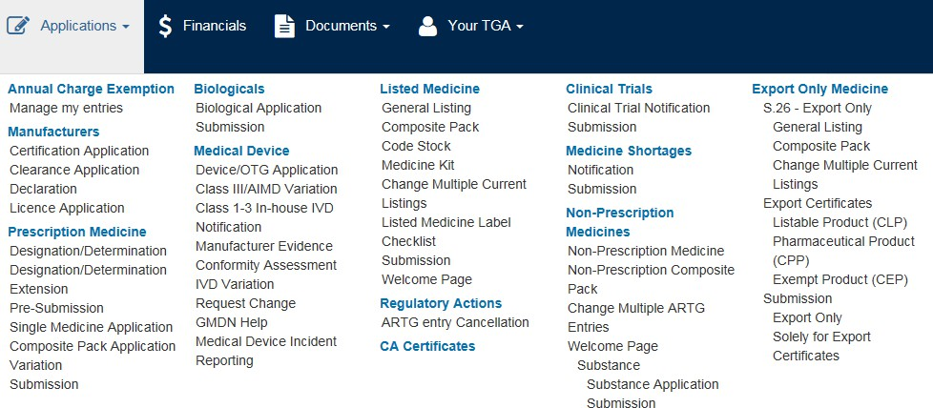

## **Variations to ODC cultivation, production, and manufacturing licences**

Prior to February 2018, export was not permitted under the *Narcotic Drugs Act 1967*. Therefore, licences in existence prior to February 2018 do not allow export and need to be varied so that the conditions allow for export. Licences issued after export became legal will have the appropriate conditions, if export was envisaged at the time of application.

If your licence does not include an activity to allow for export you will need to apply to ODC to have the licence varied.

# How to vary your ODC licences

Your licence will need to be varied if you wish to:

* + export medicinal cannabis
  + supply a TGA-licensed manufacturer directly, without going through an ODC manufacturer If your medicinal cannabis cultivation, production, or manufacturing licence needs to be varied:
  + Contact ODC:
    - [ncs@health.gov.au](mailto:ncs@health.gov.au) for narcotic drug manufacture licence variations
    - [mcs@health.gov.au](mailto:mcs@health.gov.au) for medicinal cannabis cultivation, production and manufacture licence variations

We will send you the variation form you will need to complete. Variation fees may apply.

## **Obtaining an ODC licence and permit to export**

The export of medicinal cannabis, which is subject to the *Customs (Prohibited Exports) Regulations 1958,* is prohibited unless the exporter holds a licence and permit issued by the Office of Drug Control.

The licence to export allows the licensee to apply for an export permit. Each individual consignment of goods requires an export permit. Export permits will include information such as:

|  |  |
| --- | --- |
| * name and address of importer and exporter | * quantities |
| * name and type of substance being exported | * validity dates |
| * overseas import authorisation | * conditions as required |



In some countries, cannabis may be ‘legal’ at a state level but not at a national level. In these circumstances the national authority responsible for import permissions might not issue such permissions because of the legal difference.

# Requirements for an ODC export licence

In addition to any requirements set out in the guidelines or application form for a licence to export, as an applicant for an ODC licence to export medicinal cannabis, you **must** ensure that:

* + You hold a state or territory licence to possess, supply and wholesale medicinal cannabis, dependent on the state or territory of the activity
  + You can demonstrate that you have taken steps to ensure adequate supply of medicinal cannabis to Australian patients, regardless of whether manufacturing a finished product or intermediate

# Requirements for an ODC export Permit

In addition to the licence requirements and requirements set out in the guidelines or application form for a permit to export, as an applicant for an ODC permit to export medicinal cannabis you **must** ensure that:

* + If the product is a finished product, that the product is entered on the ARTG and that there are no conditions preventing the product being exported to that country
  + The manufacture was authorised under the *Narcotic Drugs Act 1967*
  + The application has an authorisation from the importing country, issued by the Competent National Authority of that country

# How to apply for an ODC export licence

To apply for an ODC export licence:

* + Complete the Application for a licence to import/export narcotic, psychotropic and precursor substances

# How to apply for an ODC export permit

To apply for an ODC export permit:

* + Complete the Application for permission to export narcotic, psychotropic, precursor substances